How to Enable Word Wrap in Notepad Demonstration

If you have received a Text File from the patient or patients caretaker, and it isn’t Word Wrapped in Notepad, simply click on the ‘Format’ tab and click on the Word Wrap option.

The Text File should now be Word Wrapped similar to the image below.

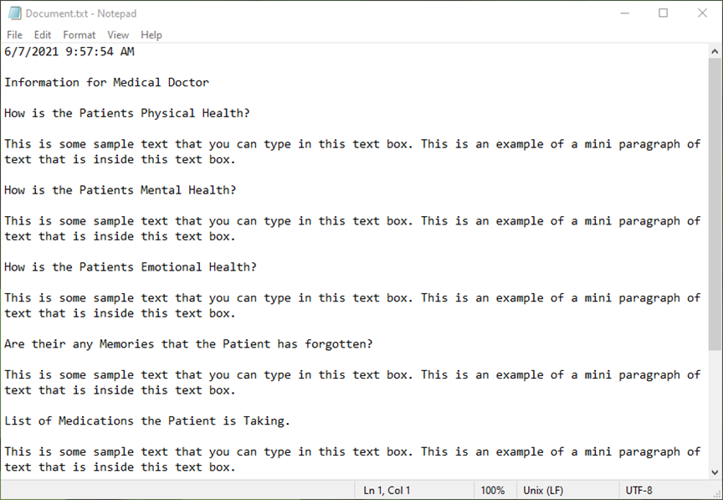

The Developer of the 3rd party Memory Tracker program, wishes you kind regards during this difficult time with your patient.